Ballaghveny Landfill - Community Gain Fund
Terms of Reference
The Community Gain Fund (CGF) was established by Tipperary County Council (TCC) for the area affected by the day to day operations of the Ballaghveny landfill, namely for the Ballymackey/Ballinree Catchment Area in the vicinity of the landfill.
The CGF shall be operated in accordance with these Terms of Reference throughout the landfilling operational phase of the Ballaghveny landfill project.

1. Function of Community Gain Fund Committee
The role of the CGF Committee shall be as follows:
- To have responsibility for the management of the Community Gain Fund.
- To decide on projects to be supported by the Community Gain Fund which will provide environmental, community, educational and recreational services and/or facilities that will benefit the local communities in the Area of Benefit or catchment area (i.e. townlands of Newtown, Derrybane, Lissanisky, Ballinree, Knockanglass, Ballymackey, Cloonmore, Lisnamoe, Ballinahemery, Riverlawn, Elmhill, Wilton, Donnybrook, Woodville, Ballaghveny, Bessborough, Ballyknockane and Brownstown) of the Landfill.
One of the main impacts on the catchment area is traffic movement into and out of the facility along the local roads L-2219-0, L-2219-14 and L-1048-0 to and from the Regional Road R-445, as indicated in the map below, in addition to the activities at the landfill itself.
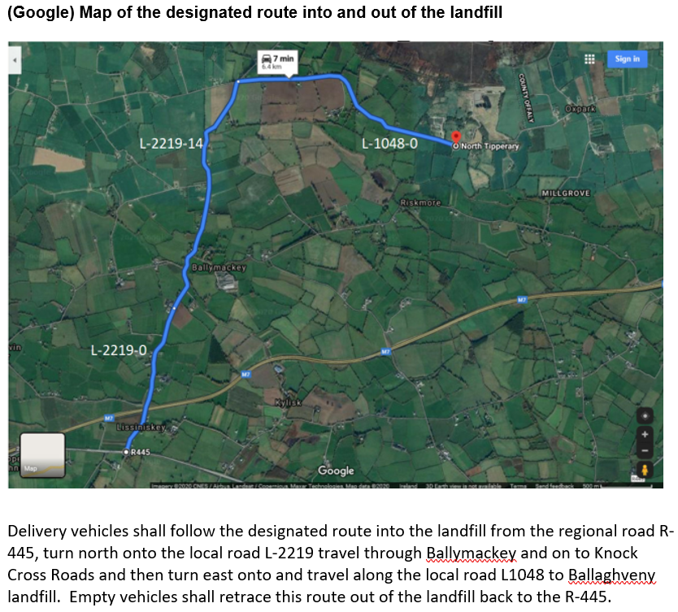
- To liaise between TCC and the local community on the landfilling phase of the project.
2. CGF Committee Membership
The CGF Committee shall comprise of the following 4 members, who will have 1 administrator to support the CGF Committee, as follows:
- two local community representatives,
- two Council officials from TCC.
The Chairperson will be selected from one of the four CGF committee members.

3. Appointment of CGF Committee Chairperson and Terms of Office
The Chairperson shall:
- be appointed for a term to be agreed with the Director of Services for the Environment & Climate Action Section of TCC.
- cease to hold office on voluntary resignation or if requested to resign by the Director of Services for the Environment & Climate Action Section of TCC.

4. Appointment of CGF Committee Members and Terms of Office
The Chairperson and membership of the CGF Committee is voluntary and shall not be remunerated.
- The Council officials and community representatives shall be appointed by the Director of Services for the Environment & Climate Action Section of TCC and shall remain a member of the CGF Committee at the discretion of the Director of Services for the Environment & Climate Action Section of TCC.
- The appointees may be re-appointed by the Director of Services for the Environment & Climate Action Section of TCC.
- The Community representatives shall be filled following a nomination or nominations from their respective sector and a selection process.
- The protocol used in selecting community representative shall be as follows:
An assessment panel shall comprise the Director of Services and Senior Executive Officer of the Environment and Climate Action Section of TCC. The assessment panel shall review the nominations using the following criteria:
- General Community Reach (Geographical and Service Delivery) – 50 marks
- Membership of community group within the area of benefit- 50 marks
- Longevity in Community Life in the Area - 50 marks
- Following the nomination and selection process, the community representative shall be appointed by the Director of Services for the Environment and Climate Action Section of TCC.

5. Role of Community Gain Fund Chairperson
- To provide leadership and direction for the CGF Committee.
- Chair meetings of the CGF Committee and manage the proceedings.
- Ensure the effectiveness of the CGF Committee in all aspects of its role.
- Take a lead role in determining and reviewing the process regarding the composition, structure and performance of the CGF Committee.
- Ensure the CGF Committee undertakes a thorough analysis of all issues and concerns presented to the CGF Committee from stakeholders.
- Ensure that all members of the CGF Committee have access to accurate, timely and relevant information.
- Ensure CGF Committee meeting protocols are maintained.
- Ensure adherence to proper corporate governance.
6. Role of Community Gain Fund Committee Members
- The CGF Committee shall be responsible for the:
  - assessment of grant aid applications, including requesting further information where deemed necessary, and
  - making of recommendations on the award of grant aid, to the Steering Committee of the Environment & Climate Action Section of TCC,
  - consider queries/appeals against grant awards and the making further recommendations to the Steering Committee on a query/appeal,
  - keeping the CGF Guidelines up to date,
  - preparing and submitting reports and recommendations to the Steering Committee.
- Assess applications for grant assistance to fund projects which will benefit the community in accordance with the Ballaghveny landfill CGF Guidelines.
- Make recommendations on the adequacy of the information received with applications for grant aid and, where necessary, to request further information.
- Make recommendations on the amount of grant assistance to be awarded from the CGF to each applicant, including the recommendation not to award a grant or grants.
- The CGF Committee shall report to a Steering Committee.
- To act as a liaison between Area of Benefit stakeholders, Ballaghveny landfill, and TCC.
- To disseminate information on the CGF to the communities as may be required by the CGF Committee.
- To analyse information and reports provided to the CGF Committee by Ballaghveny landfill or on their behalf.
- To make recommendations to the Steering Committee on changes to be made to the Ballaghveny landfill CGF Guidelines.

7. CGF Committee Meetings
- The CGF Committee shall meet at least once per year with additional meetings scheduled as required and as agreed by the members.
- The quorum shall be three members.
- The date, time and location of each meeting will be scheduled by the CGF Committee as required.
- The administrator shall be responsible for preparing and distributing the agenda and minutes of each meeting.

8. Role of Steering Committee
- The Steering Committee will comprise of the Director of Services and Senior Executive Officer of the Environment and Climate Action Section of TCC.
- The Steering Committee will consider and, where appropriate, take the grant recommendations of the CGF committee to the elected members of Nenagh Municipal District for ratification.

8. Ballaghveny landfill Community Gain Fund Guidelines
- The CGF Committee shall be responsible for assessing and recommending the disbursement of funds from the Community Gain Fund, to qualifying projects, in accordance with the Community Gain Fund Guidelines (which may be amended from time to time by TCC).
9. Annual Report & Audit
- The CGF Committee shall prepare an Annual Report and shall be circulated to all TCC Councillors and made publicly available. It shall include the following:
  - A review of the Ballaghveny landfill Community Gain Projects Grant Scheme and the projects supported by it.
  - A review of the Community Gain Fund finances.
- The Local Government Auditor and the TCC Internal Auditor may audit the Ballaghveny landfill Community Gain Fund accounts.

