NATIONAL FIRE SAFETY WEEK
6th - 13th October 2019

CALLING ALL
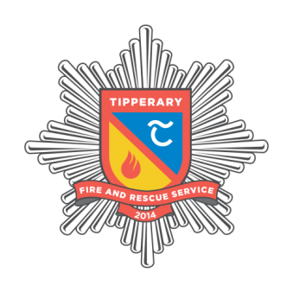
Tipperary Primary Schools

Win a €250 Eason’s voucher for your class

To be in with a chance create a short Fire Safety song or rap video
Entries can be sent to FireSafetyWeek@tipperarycoco.ie
Together with your School & Teacher details no later than 1st Oct 2019
Winning Rap will be posted on social media

